Table of Contents

Introduction 2

What needs to be done? 3

Who is going to do the tasks? 4

Work breakdown structure 5

Work Distribution: 6

Shirwa: 6

Mohamed: 6

Dependencies 6

Work Scheduling 7

Tasks that need to happen for Technical Specification implementation 8

What presently been done? 8

Conclusion: 9

PROJECT PLAN

CCE4999 PROJECT ACTIVITY

MOHAMED AL-JANABI M00461666

SHIRWA HAJI

# Introduction

The purpose of this document is to serve as a systematic and reasonable approach, to the allocation of workloads and deliverables. A project plan must fully map out; who does what, and when things will happen.

Furthermore, this is a breakdown of the work packages that will be developed and tested to deliver the elements necessary, appropriate and fit for a project of this scope.

A carefully devised and well thought through project plan can make a different between success and failure. It is therefore up to the team players to make sure this can be implemented, by listing certain tasks and operations that must happen within a reasonable timeline, through approximate calculations.

As no project plan is ever guaranteed to reach a 100% expectation mark, it can however act as a guideline and the team players can refer to it systematically and work in harmony with it. It is the responsibility and duty of the team players, to make sure they can delegate and work in accordance.

Co-coordination, consistency and co-operation are key to making this project a success.

* What tasks need to happen to implement the technical specification and how long they’re going to take?
* Identifies all the tasks that are going to be done
* Who is going to do the tasks?
* How long the tasks are going to take and what their dependencies are?
* Should include all the elements of the design
* Focus on trying to estimate all the stuff that we need to do
* Should include a plan for the whole project, including the stuff that’s already been done
* Note down estimations on how long **ALL** tasks are going to take, including what’s presently been done

## What needs to be done?

A project of this scope needs profound research time and careful analysis of all components and elements. They must blend in harmony and make sure that all the components and elements harness appropriately. For such, if any of these components are picked out of hastiness, due to poor lack of time management skills, then this can result in unnecessary delays. These delays can be avoided with good time management skills, which is really what the IT industry demands.

First, there has to be an evaluation of the 6DOF Stewart Platform chair. The reason this is important is because the team players have to become familiar with the mechanisms and dynamics of the chair. It is also useful to take pictures and film footage, in order to analyze where certain hardware devices (e.g. sensors) will be assembled. This saves unnecessary delays and leg work.

The team players must also meet up to study the 3 modules that will be built and in what programmed language is deemed fit. The 3 modules that need to be created are: Watcher (now known as ***Monitor***), Test Command Server and Sensor Server.

Once it has been decided what programming language will be used to build the 3 modules, the participant must take it upon himself to study the programming language and create the modules.

While all this is going on, the other member must research into appropriate sensors that meet the reading measurements criteria for the project. This will be documented and a range of sensors will be considered, as well as including the costs.

In summary this is what needs to be done for the preliminary stage of the project:

* Analyze the 6DOF Stewart Platform Chair
* Take pictures of the chair and film footage for referral means
* Study the project brief and decide on a suitable and appropriate programming language for the 3 modules
* Research into sensors and microcontrollers, in order to help complete this project successfully
* Meet with co-partner and present findings on suitable hardware’s
* Divide the workload between the members and agree to frequent meetings, to reflect on current progress and advance

## Who is going to do the tasks?

This can simply be answered by referring to the allocation of tasks in the subsequent pages. The allocation of tasks helps in cutting down the workload, in which every team player has his ‘niche’. This ‘niche’ is about facing up to the challenges and committing to them.

**Shirwa** will solely focus on the technical and practical side of the project. The actual execution of tasks can be seen on page 4. The *technical side* of the project is only a consolidated term, for the half of the project he is committed to. He is mainly responsible for the hands on practicality of the project.

This includes:

Wiring up of the microcontrollers, configuring sensors, obtaining sensor readings, measuring sensor data.

**Mohamed** will focus on the remainder of the project, which involves a chunk of coding to be implemented, for the 3 modules to be created. The opted programming language is Python scripting. A compilation of literature mixed with technical information will also be written up, in order to make sure the work flow is consistent, professionally formatted and documented.

This is mainly:

**Informatics Research based** – Researching into sensors and assessing the value it has to the project. Researching into the 6DOF Stewart Platform chair is also an appropriate example. It is a means of assessing the physical nature and dynamics of the chair, how it behaves and how it responds.

**Programming research based** – Researching and learning about Python scripting, in application to the 3 modules.

**Literature research based** – A good example of this is looking into appropriate sensors that match the accuracy requirements.

**General overview** – This is making sure the entirety of the project is progressing naturally and that each member is applying consistent and continual effort.

**Conducting Meetings** – This is a frequent process in which the 2 members meet and discuss what’s outstanding.

To keep an open mind and engage with third party sources (Eric). This helps in obtaining relevant experience, which can save detriment to this project, just by communicating and seeking a third party opinion.

# Work breakdown structure



# Work Distribution:

## Shirwa:

* Liaise with Eric to configure R101 microcontroller, for angular measurements. **2 DAYS**
* Careful wiring up of the (integrating i2c communication) microcontrollers and sensors. **1 DAY**
* Running tests of the sensors and diagnosing any problems during the process. **7 DAYS**
* Implementing C coding and applying this to the selected microcontrollers and sensors. **3 DAYS**
* Testing and debugging the system. **2 DAYS**
* Assembling of the software & hardware. **1 DAY**
* Arduino 101 sensor is specifically going to be used for angular sensors, so this needs to be thoroughly looked into. **3 DAYS**
* Obtain relevant and appropriate coding’s from Eric. **2 DAYS**
* Cross check coding’s and report malfunctions back to Eric if need be **2 DAYS**
* Performing actual measurements. **1 DAY**

## Mohamed:

* Research into C programming codes for programming Arduino sensors. **7 DAYS**
* Learning Python coding for modular communications. **7 DAYS**
* Implementing Python coding for the 3 modules. **7 DAYS**
* Write up the project and address every progress and make sure the information is consistent & clearly documented. **7 DAYS**
* Check for any irregularities and backtracking if need be. **2 DAYS**
* Conduct meetings with partner and make sure that all the information supplied is final. **3 DAYS**
* Reference work appropriately and proof reading it. **3 DAYS**
* Relay feedback back to partner and finalize work. **3 DAYS**
* Conduct meetings with partner and come to common terms on what’s agreeable and outstanding **3 DAYS**

## Dependencies

There are a variation of dependencies that are key to making sure there are no setbacks.

* Coding cannot begin on the sensors until suitable sensors have been selected
* Coding cannot begin on the microcontrollers, until it has been decided which microcontrollers are appropriate
* Shirwa is responsible for making sure the implementation, design and practical information is relayed to Mohamed. Without this, there can be no documentation and can result in unnecessary time being wasted
* Without frequent meetings, there can be no progression, only the assumption that everything is fine at present
* Coding of the sensors have to be programmed accurately. By accurately, this means; error, syntax and compilation free
* Slave devices (Mega boards) have to be sending data at the same time to the Master (R101)
* The cylinder that generates the pressure to be applied to the actuator, is in full operation and free from defect

# Work Scheduling

Below is a work scheduling format, which covers the duration of 24 weeks, starting from October 2016. Each independent task has a specified duration (in weeks), which is an approximation on how long the tasks will take. The documentation task is a continuous process, which is most demanding and requires constant attention. This requires frequent modifications and additions, which runs concurrently with other tasks.

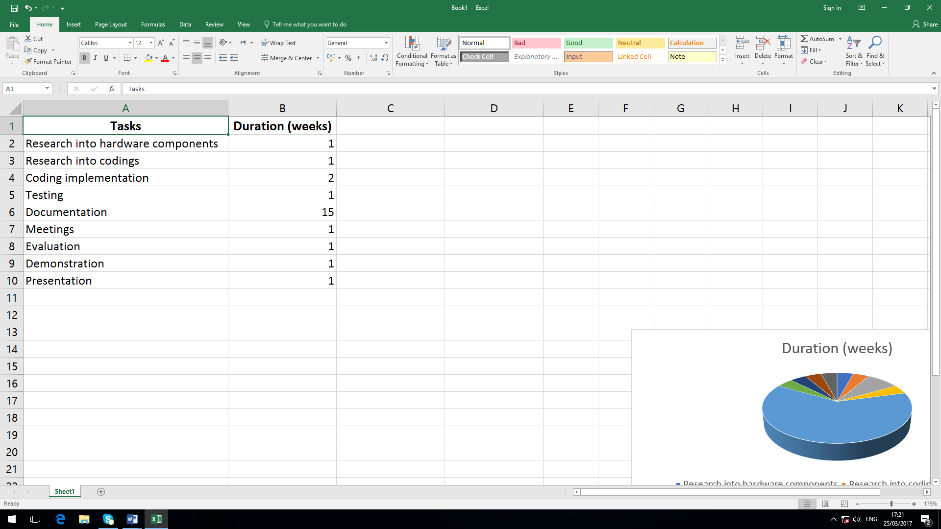

# Tasks that need to happen for Technical Specification implementation

The tasks that need to happen for Technical Specification implementation are:

* Establishing communications between the Arduino Megaboards (Slave devices) and making sure they send data to the Arduino R101
* The creation of error detection mechanisms and error correction handling
* Testing debug functionality
* Understanding sonar technology for the sensors, via their response time and behavior ( since the sonar sensors emit sound waves)
* Test benching and experiment on sensor readings, whether there is interference or not
* Learning Python and C coding for implementation - **Python coding is used for the modules and C coding is used for both sensors and microcontrollers**
* Establishing sensors and microcontrollers communication with the computer system
* Obtaining weights for the use of chair calibration (each Client is of different body mass – For experimental use only)
* Obtaining sensor readings
* To conduct research into i2c protocol for boards communication
* Establishing Middleware communication with the chair
* Configuring TCP port for system communication with the chair

# What presently been done?

The communication between the Slave devices (Megaboards) and the R101 has been established. There slave boards send dummy data, but the readings keep fluctuating and the readings are occurring at a very fast rate.

# Conclusion:

This document looks to encapsulate what tasks need to be addressed and what the realistic timelines.

It has already been mentioned that the programming for the 3 software modules will be programmed using Python scripting. The sensors will be programmed using C programming. The selected use of programming languages was chosen due to simplicity, past minor and contemporary experience.

However, it was important to address every key element explicitly and comprehensively, in order to harmoniously combine all components. The remainder of the project should unfold and progress naturally, without any hindrances or further difficulties.